Brief Profile of
Chetana Empowerment Foundation

- De-addiction Awareness Program
- Education Support to Scholar and Needy Students
- Empowerment

Presented by:
Chetana Empowerment foundation
72, Mahajan colony, N2, Cidco, Aurangabad-431210

CHETANA EMPOWERMENT FOUNDATION
Nature of Activities: De-addiction Awareness Program Education Support to Scholar and Needy Students
Empowerment

Organization: Chetana Empowerment Foundation
Office Address: 72, Mahajan Colony, Cidco, N2, Aurangabad -431210
Year of Establishment: August 2013
Registration Date: 06/08/2013
Registration Number: a) Society Registration Act, 1860. No: MH-869/13 Dt.6/8/13.
b) Bombay Public Trust Act, 1950.Reg.No. F-20455 (A)
c) Income Tax Act 1961 12AA- Reg.No.2621/2014-15 Dt.23/07/14.
d) Income Tax Act 1961, 80G-Regina.PN/CIT/ (Exempt)/Tech/80G/79/Abad Range/2-14-15/858.

Registration Type : Bombay Public Trust Act, 1950.Reg.No. F-20455 (A)
Society Registration Act, 1860. No: MH-869/13 Dt.6/8/13.

Contact Person: CA Vivek Randad
Position in Organization: President of CEF
Contact No: +91 7722035441
Email Id: chetana.emp@gmail.com

INTRODUCTION:
- Chetana Empowerment Foundation has undertaken an uphill task of providing platform to individuals for world transformation through self transformation since Nov 2012. It has drawn up a comprehensive plan to bring about a new awakening among the Society.
- This organization was formed with the main purpose of individual’s all round growth and development, which includes physical, intellectual, moral, spiritual and social enrichment and lasting peace and happiness.
- It is a group of young couples, who, in addition to performing all their regular duties, lead a life free from unhealthy habits, competition and spend their spare time and energy in rendering voluntary services for the upliftment of the society. They participate in retreat and meditation camps to develop positive attitude, strong moral values, divine manners and all –round personality. Chetana have a strong group of well-educated, experienced and dedicated team to execute the planned projects.

VISION:
- To facilitate the attitude of brotherhood, unconditional love, and tolerance
- I shall change myself, set an example and the world will change.
- I step forward with the courage to take-up the responsibility.
- No more excuse, now I shall work for the results and shall join hands in creating Swarnim Bharat.

1.1 Mission and Running Activities :

1) De-Addiction:

2) Education

a) Higher Education Financial Aid

b) Student residential scheme (Chetana Jeevan Nirman)

3) Empowerment:
a) Youth empowerment
b) Women empowerment
c) Child empowerment

Empowerment:
To organize Meditation retreat, seminars, and workshops for Self-Empowerment of Youth, Women and Married couples by arranging Motivational, Inspirational talks by inviting expert faculty.
Need of Empowerment:
In this day and age, mankind has achieved an incredible degree of success which is mainly confined to the outer aspects (exterior to our inner being). However, many of us, surprisingly, find ourselves struggling with achievement of inner stability, peace and personal harmony.
We also strive for consistent satisfaction in our thoughts and deeds. In the true sense we need Self-Empowerment.
We all get knocked down so that we can stand up again. Challenges are always going to punch you in the face, so through motivational talks one get courage to fight back.
We strongly believe that the self-empowerment will lead to the Social Empowerment. To achieve our objectives of self empowerment, We undertake meditation program, training camps, retreat programs, conferences, seminars, workshop, lecture series and value based session.

Under this objective we mainly focused on:
a) Youth empowerment
b) Women empowerment
c) Child empowerment

A) Youth Empowerment
Objective of Youth Empowerment Program:
Have you ever felt that there is something beyond completing your education and having a safe job.
Do you get motivated to use your talents to grapple with the several Social, Scientific and Technological challenges around.
Does the question of finding the purpose of your life move you.
Chetana is a platform for youths and others with such a burning desire to come together and seek answers to these questions.
Chetana is the place to know you fully and find your life mission. Chetana is a pursuit of leading a meaningful life.

Following activities are mainly undertaken under this:
- Arranged seminar of Sandeep Maheshwari for 1500 Youth , Women, Couples, on subject interactive Q & A session on Last life changing seminar, 16th March 2013 at Sant Tukaram Natyagraha, N-5, Aurangabad
- Arranged Value Based Session For Teenagers on Subject Mind Management for Successful Career, 300 Students attended the program at Deogiri College of Engineering, Aurangabad 20th Sept 2014.
- Arranged One Day Self empowerment Program on Subject Hausolon Ki Udaan 450 Students attended the Program at Institute of Engineers, Aurangabad, 22nd August 2015.
- Arranged One Day self empowerment Program on Subject Hausolon Ki Udaan 250 Students attended the Program at MGM Conference Hall , Aurangabad, 03rd September 2016.
- Arranged Two Days Youth Empowerment Program on Subject Rediscover the Vision & Mission of Life 125 Students attended the Program at Massicon Hall, MGM Campus, Aurangabad. 28th & 29 Jan 2017.
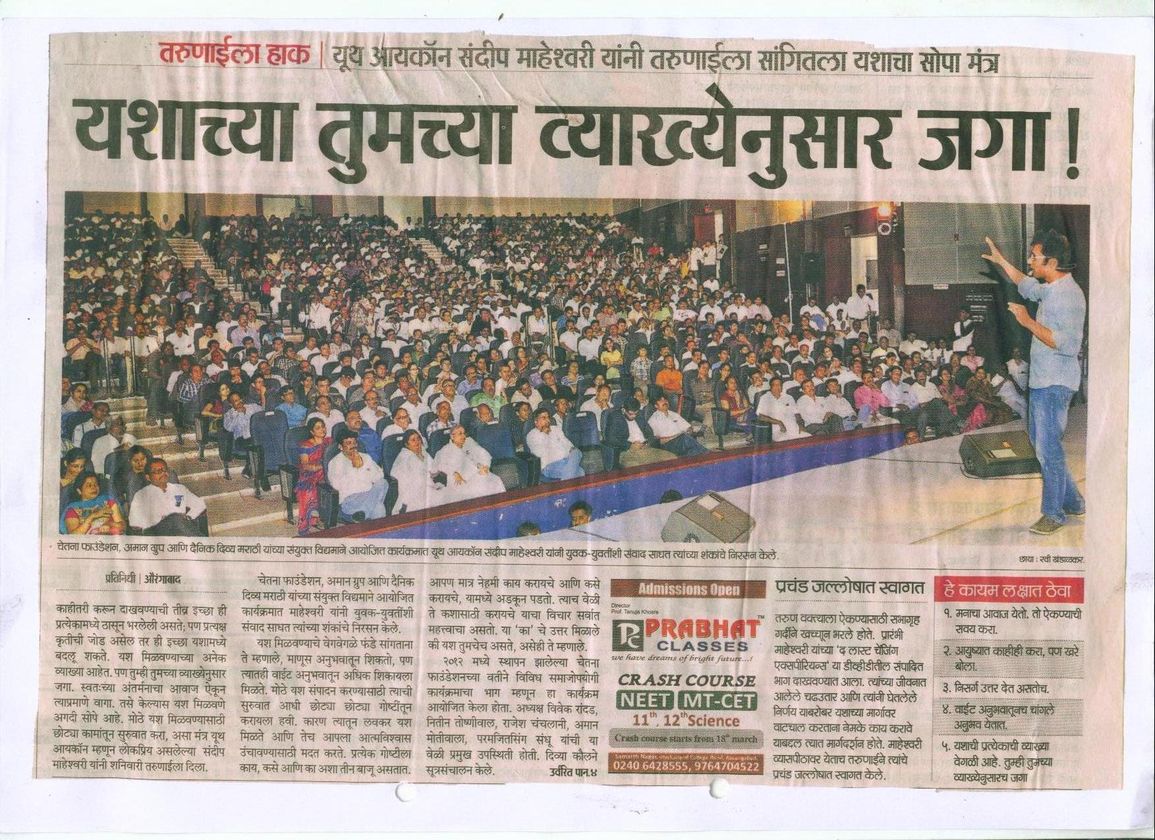

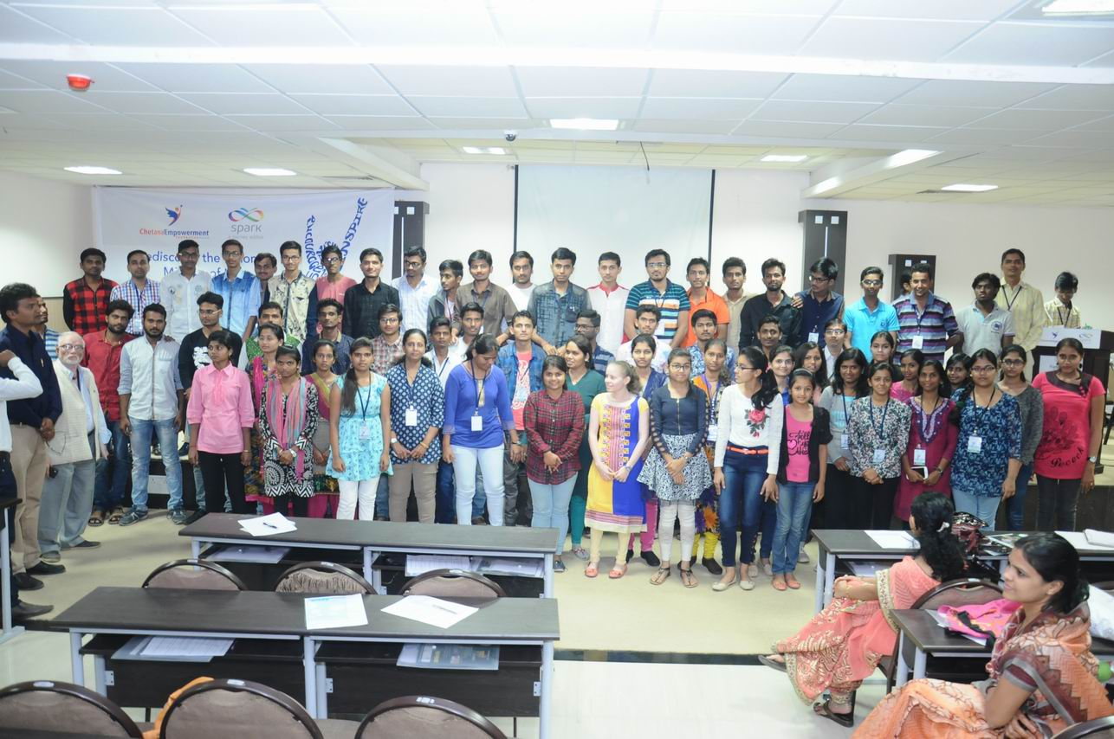
B) Women & Couple Empowerment:
- Understanding one self thoroughly.
- With the help of Meditation explore self & develop positive life style.
- Strengthen the interpersonal relationship for harmony in life.
- To understand the core values for change in self and for better parenting.
- Interaction with eminent change makers from various fields.
- Life mission: what does it means. Do I need to have one? How do I Identify it..
Following activities are mainly undertaken under this object:
- Arranged seminar of Dr.Prem Masand for 800 Youth, Women, Couples on subject Peaceful Powerful and Purposeful Living, on 20th June 2013 at Sant Eknath Rangmandir, Aurangabad.
- Arranged seminar of Prof. E. V.Swaminathan for 400 people on subject Celebrating life with Happiness, on 19th Oct 2013 at Yashwantrao chavan Natyagraha, Aurangabad.
- Arranged 4 days “Hyderabad Retreat Program” of Ajitji, Sister Radhika, Rameshji Partani, Anita Kaswer, Sarita Rathi, in Jan 2014 on subject Self empowerment retreat Program for 125 People at Shanti Sarovar, Hyderabad.
- Arranged One Day self empowerment Program on Subject Discover The New Horizon of Life at Sagar Lawn, 16th Feb 2014.
- Arranged Two days seminar for 600 people on Subject Self Change for social change at Babasaheb Ambedkar Marathwada University, 28th and 29th Jun 2014.
- Arranged Two Hours self empowerment Program on Subject “Positive Thinking” 150 Women attend the program at Samarth Nagar, Aurangabad 1^{st July} 2014.
- Arranged Value Based Session Program on Subject “Balancing Health, Wealth & Happiness” 400 Youth, Women, Couples attended the program at Institute of Engineers, Aurangabad, 20th Sept 2014.
- Arranged One Day self empowerment Program on Subject “Stress Free Management” 700 Youth, Women, Couples attended the program at Sant Tukaram Natya Gruha, Aurangabad,10th Jan 2015.
- Arranged Five Days self empowerment Program on Subject Meditation Retreat for Happy & Healthy Life 110 Participants attended the Program at Chetana Hall Cidco N-2, Aurangabad, 6th to 10th August 2015.
- Arranged three Days Self empowerment Program on Subject Secret of Ultimate Living 500 People attended the Program at Institute of Engineers, Aurangabad between 19th to 21st Feb 2016.
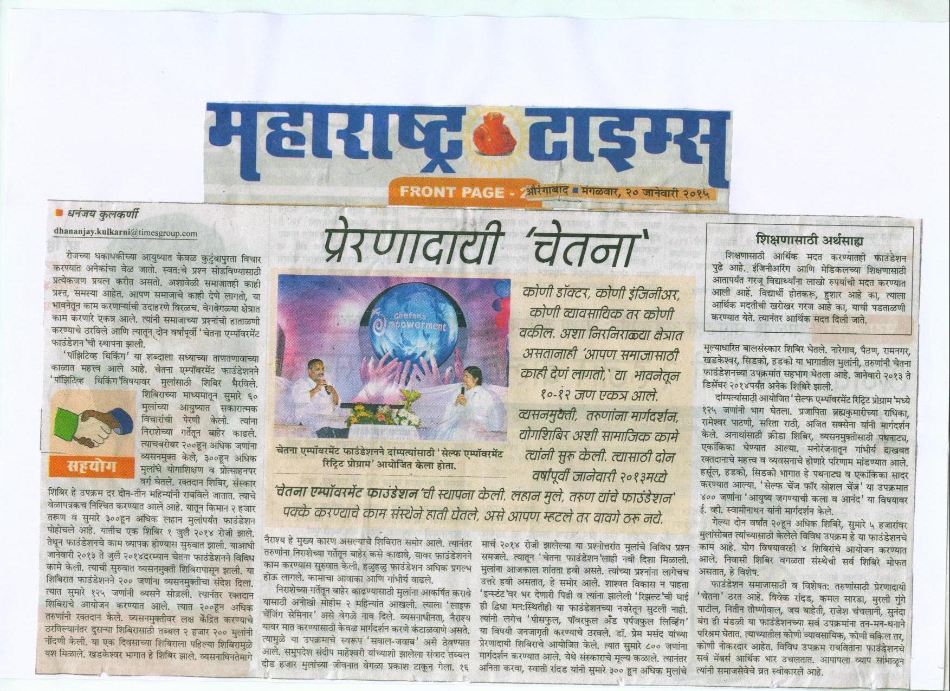
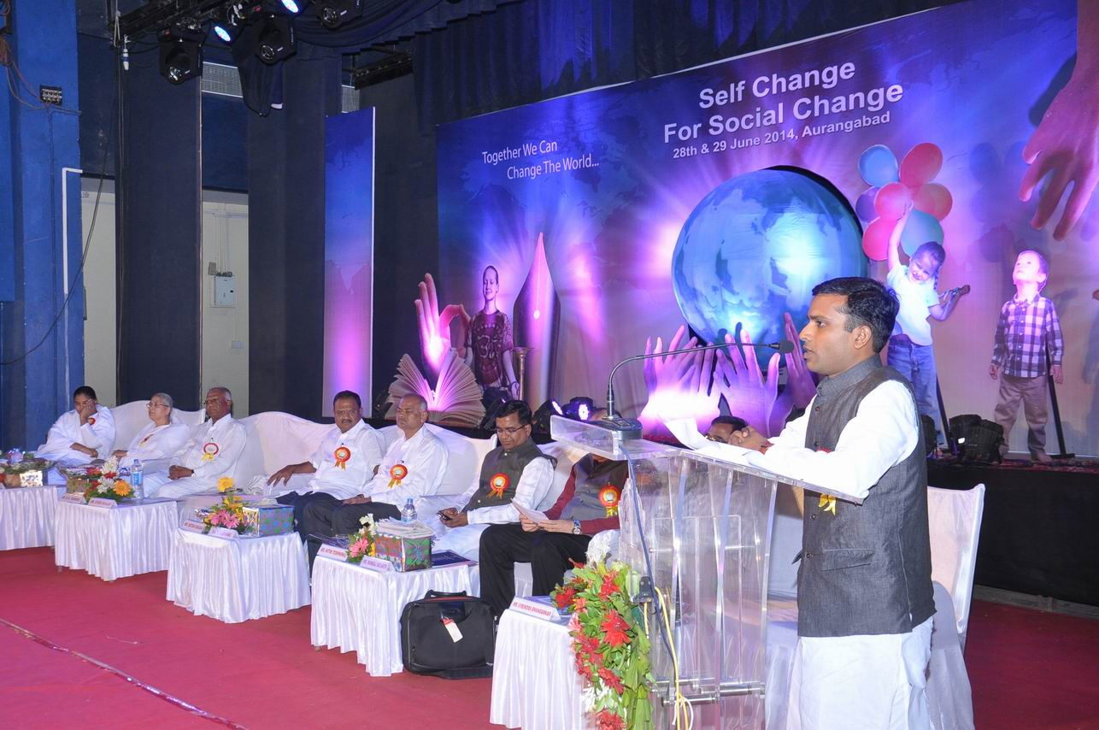

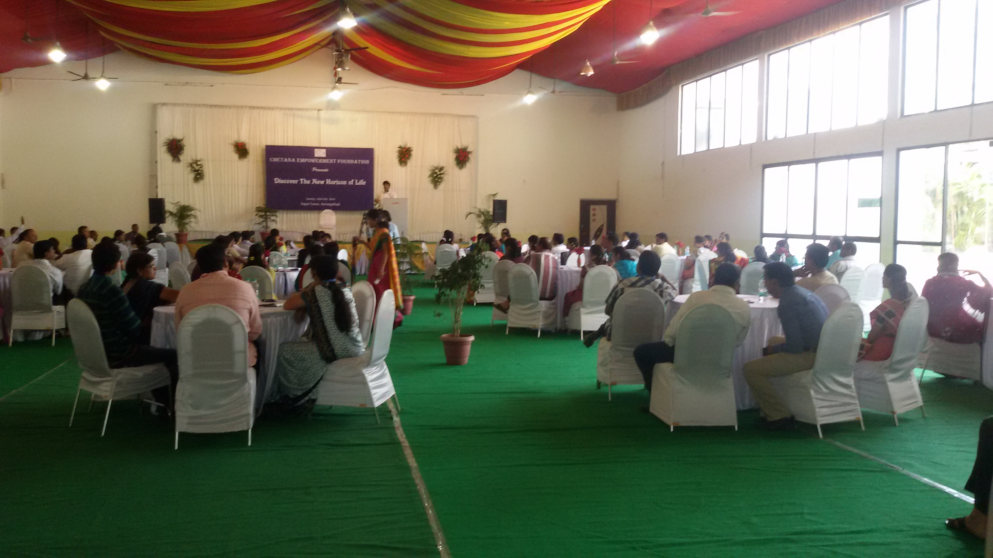
C) Child Empowerment
- To conduct Value Based Training Programs for children between the age group of 5 to 14.
Our education system is developed in such a way that where concentration is given to develop children intellectually powerful but no efforts are taken to develop them emotionally capable and henceforth depression is increasing in children at very small age. To face this challenge, we have considered moral and spiritual education as an essential part of our education system and will make efforts to adopt moral and human values for their peace, progress, growth and all round development to make them confident for their future life.

Following activities are mainly undertaken under this object:
- Arranged 4 days “Sansakr Shivir” for 125 childrens in April 2013 containing Meditation, Yoga, Value based activities, session, games and most importantly a full day workshop on parenting for their parents conducted by Expert faculties.
- Arranged 5 days “ Bal Chetana Sanskar shivir” for 125 childrens in April 2014 containing Meditation, Yoga, Value based activities, session, games and most importantly a full day workshop at Tapdiya Innovation School
- Arranged 7 days “ Bal Chetana Sanskar shivir” for 125 childrens in April 2015 at MGM Sports Club Aurangabad containing Swimming, Meditation, Yoga, Value based activities, session, games and most importantly a full day workshop for Parents.
- Arranged 7 days “ Bal Chetana Sanskar shivir” for 90 childrens in May 2016 at MGM Sports Club Aurangabad containing Swimming, Meditation, Yoga, Value based activities, session, games and most importantly a full day workshop for Parents
- We are providing Value education with Meditation daily to 50 students (6th to 9th Std.) and also teaching them Science, Mathamatics and English who belong from slum society from last four months at Chetana hall, 72, Mahajan colony.
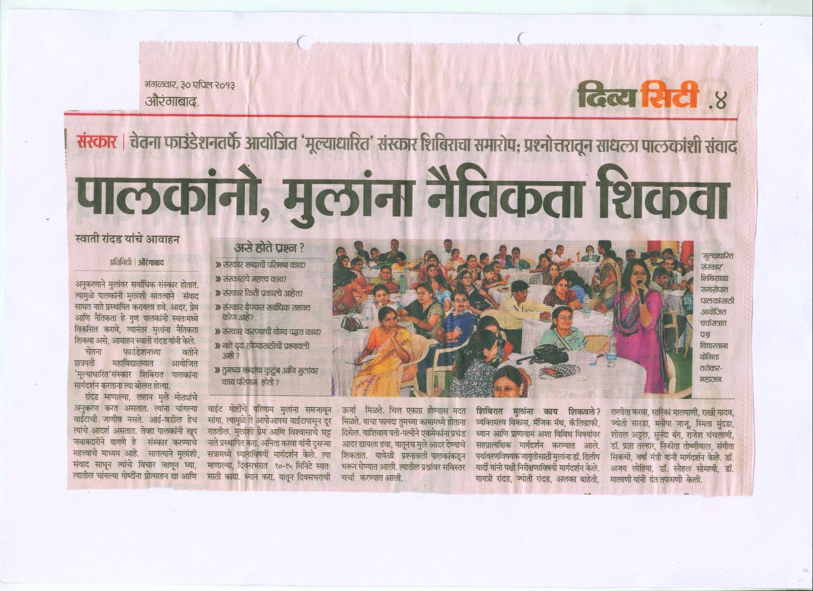
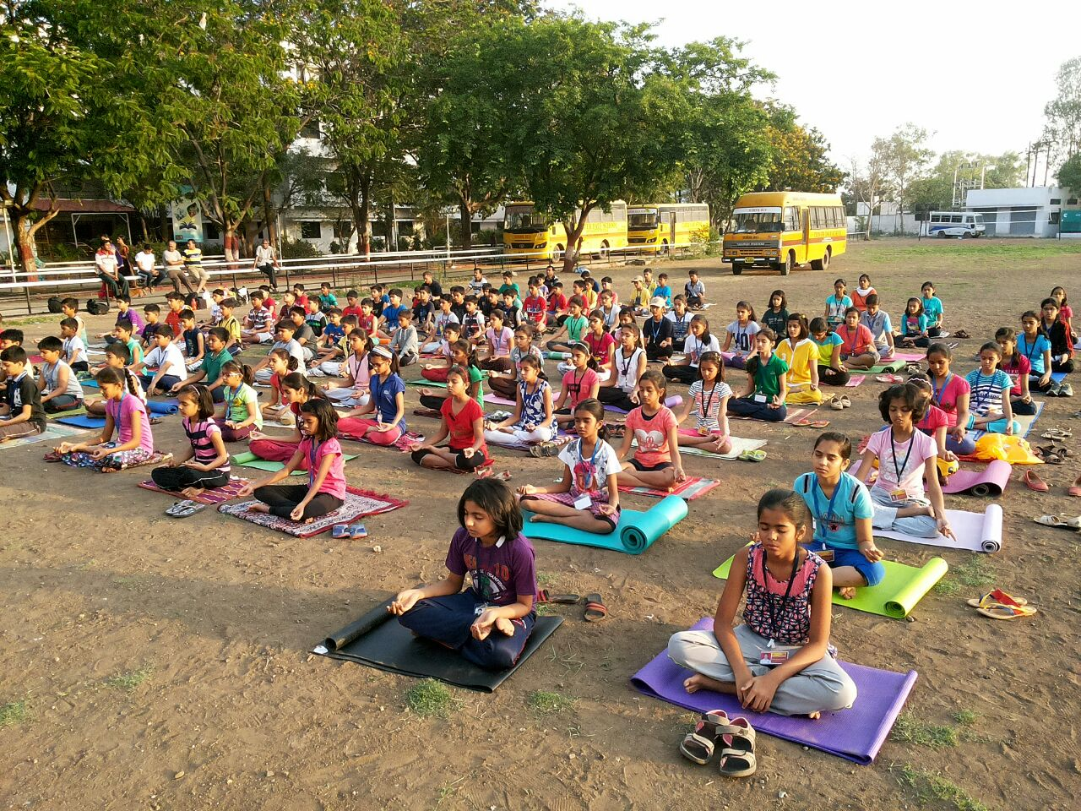
NEED OF EMPOWERMENT & TRANSFORMATION TRAINING CENTRE:
Trust Management has proposed to provide various residential as well as non residential empowerment and meditation training programs, for youth, couple, women and children from age group of 7 to 14 years (i.e. Sanskar Shivir). Along with this we have planned to arrange residential Corporate training program like Self Management Leadership, Stress Free Management, Positive Thinking, Harmony in Relationship etc program at periodic intervals. For this mission of empowerment we require our own campus having a good ambience to take such programs regularly and for that following infrastructure need to be developed over there.

- Seminar Hall
- Meditation Center
- Accommodation for 75 individuals
- Dinning
- Kitchen
- Landscaped Garden
- Multipurpose Hall

MANAGEMENT:
We have group of 40 Faculties & volunteers who are committed to work for empowerment of these people.
We have also decided to appoint Full time administrator, Nursing staff, care taker, Cook and Other supporting staff for providing thorough care of the participants.
One of our trustee’s family members has expressed to stay over there full time for regular monitoring of working, administration and their daily schedule.
Our other trustees and members will also monitor the administration of this campus on rotation basis in the group of 3. We will form 6 such groups so that each group will devote time for 2 months in a year.

Capital Cost of Project:
Sr.No | Particulars | Area | Budget Amt in Rs.(Lakhs)
1 | Meditation Hall | 1425 Sqft | 13.00
2 | Water Tank (One ) | 100000 Ltr | 07.00
3 | Dinning & Kitchen | 1600 Sq.Ft | 25.00
4 | Seminar Hall | 1200 Sq.Ft | 20.00
5 | 10 Residential Cottage (Attached Bathroom) i.e. 40 Occupancy | 3750 Sq.ft | 50.00
6 | 8 Rooms, Residential Building for Staff & Volunteers | 2000 Sq.ft | 34.00
7 | Other |  | 16.00
 | Total Budget |  | 165.00
Means of Finance:
Sr.No | Contributors names | Percentage | Total Amount in Rs.
1 | Own Contribution | 40 % | 66.00
2 | From Donors | 60% | 99.00
 | Total |  | 165.00
Inwards : One Crore and Sixty Five lakhs rupees only

